**Multiple Choice Questions**

**Instructions**

1. **You cannot choose more than one**
2. **Negative marking**

1. The correct matching of the following pairs is

(a) Disk check              (1) Roundrobin

(b) Batch processing        (2) Scan

(c) Time sharing            (3) LIFO

(d) Stack operation         (4) FIFO

1. (a, 3) (b, 4) (c, 2) (d, 1)
2. (a, 4) (b, 3) (c, 2) (d, 1)
3. (a, 3) (b, 4) (c, 1) (d, 2)
4. (a, 2) (b, 4) (c, 1) (d, 3)

2. What does the following function do for a given Linked List with first node as head?

void fun1(struct node* head)

{

  if(head == NULL)

    return;

  fun1(head->next);

  printf("%d  ", head->data);

}

1. Prints all nodes of linked lists
2. Prints all nodes of linked list in reverse order
3. Prints alternate nodes of Linked List
4. Prints alternate nodes in reverse order

3. A program P reads in 500 integers in the range [0..100] representing the scores of 500 students. It then prints the frequency of each score above 50. What would be the best way for P to store the frequencies?

1. An array of 50 numbers
2. An array of 100 numbers
3. An array of 500 numbers
4. A dynamically allocated array of 550 numbers

4. Let A be a square matrix of size n x n. Consider the following program. What is the expected output?

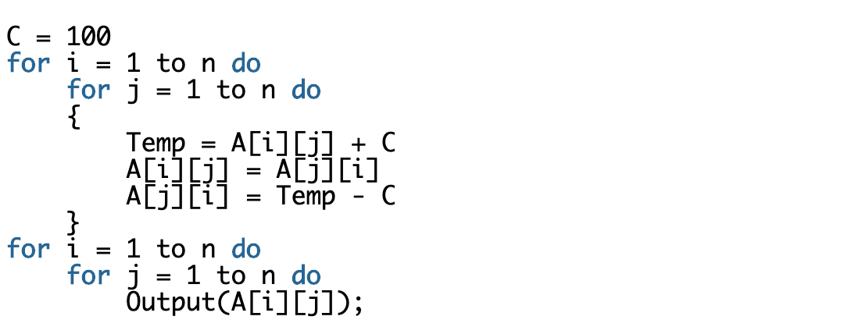

1. The matrix A itself
2. Transpose of matrix A
3. Adding 100 to the upper diagonal elements and subtracting 100 from diagonal elements of A
4. None of the above

5.    The _________ time in a swap out of a running process and swap in of a new process into the memory is very high.

a.    context – switch

b.    waiting

c.    execution

d.    all of the mentioned

6. Secure shell (SSH) network protocol is used for __________

a) secure data communication

b) remote command-line login

c) remote command execution

d) all of the mentioned

7. What is the time complexity of following code:

int i, j, k = 0;

for (i = n / 2; i <= n; i++) {

   for (j = 2; j <= n; j = j * 2) {

       k = k + n / 2;

   }

}

1. O(n)
2. O(nLogn)
3. O(n^2)
4. O(n^2Logn)

8. Number of characters can fit in 2GB RAM? **2^31 char of a byte each**

9. Which of the following are **not** shared by threads?

A. program counter

B. stack

C. Code section

D. Global variables

10. Which data structure is used in redo-undo feature?

1. Stack
2. Queue
3. Tree
4. Graph

11. What is recurrence for worst case of QuickSort and what is the time complexity in Worst case?

1. Recurrence is T(n) = T(n-2) + O(n) and time complexity is O(n^2)
2. Recurrence is T(n) = T(n-1) + O(n) and time complexity is O(n^2)
3. Recurrence is T(n) = 2T(n/2) + O(n) and time complexity is O(nLogn)
4. Recurrence is T(n) = T(n/10) + T(9n/10) + O(n) and time complexity is O(nLogn)

12. What is time complexity of fun()?

|  |
| --- |
| int fun(int n)  {    int count = 0;    for (int i = n; i > 0; i /= 2)       for (int j = 0; j < i; j++)          count += 1;    return count;  }   1. O(n^2) 2. O(n*Logn) 3. O(n) 4. O(n*Logn*logn) |
|  |

13: An array consist of n elements.We want to create a min heap using the elements.The time complexity of building a heap will be in order of

1. O(logn)
2. O(n)
3. O(n * logn)
4. O(n * n)

14. Which of the following sorting algorithms has the lowest worst-case complexity?

(A) Merge Sort

(B) Bubble Sort

(C) Quick Sort

(D) Selection Sort

15. Which of the following transport layer protocols is used to support electronic mail?

(A) SMTP

(B) IP

(C) TCP

(D) UDP

16. A system has n resources R0,…,Rn-1,and k processes P0,….Pk-1.The implementation of the resource request logic of each process Pi is as follows:

if (i % 2 == 0) {

      if (i < n) request Ri

      if (i+2 < n) request Ri+2

}

else {

      if (i < n) request Rn-i

      if (i+2 < n) request Rn-i-2

}

In which one of the following situations is a deadlock possible?

(A) n=40, k=26

(B) n=21, k=12

(C) n=20, k=10

(D) n=41, k=19

17. Which of the following data structure/s is best suited for converting **recursive implementation to iterative implementation** of an algorithm?

1. Queue
2. Stack
3. Tree
4. Graph

18. The **Breadth First Search** algorithm has been implemented using the queue data structure. One possible order of visiting the nodes of the following graph is

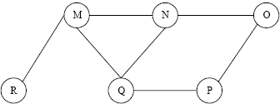

1. MNOPQR
2. NQMPOR
3. QMNPRO
4. QMNPOR

**Programming Questions**

**Instructions**:

1. Write code in programming language of your choice.
2. With each question also **mention time and space complexity**.
3. While evaluating these questions, the main emphasis will be on correctness of main algorithm
4. You can use standard library functions like sort, min, max.

**1)** Suppose you have a deck of cards represented as a linked list. You can perfectly shuffle

that list by cutting it at the halfway point, then interleaving the two halves by alternating back and forth between the cards. For example, suppose you want to perfectly shuffle

this sequence:

 1 2 3 4 5 6 7 8 9 10

You'd start by splitting it into two halves, like this:

 1 2 3 4 5 6 7 8 9 10

Then, you'd interleave the halves, like this:

6 1 7 2 8 3 9 4 10 5

The resulting list is said to have been perfectly shuffled. Your job is to write a function that accepts as input a linked list with an even number of elements, then rearranges the elements in that list so that they're perfectly shuffled.

Time Complexity – O(n)

Space Complexity – O(n)

class Node:

    def __init__(self,val):

        self.val=val

        self.next=None

class Linkedlist:

    def __init__(self):

        self.head=None

    def create_list(self,array):

        temp = self.head

        for i in array:

            new_node = Node(i)

            temp.next = new_node

            temp = new_node

    def print_list(self):

        temp = self.head

        while temp != None:

            print(temp.val)

            temp = temp.next

    def list_shuffle(self):

        if self.head == None:

            return

        #dummy = Node(None)

        #dummy.next = self.headhead

        slow = self.head

        fast = self.head

        numberofnodes = 0

        while fast!=None:

            slow = slow.next

            fast = fast.next

            numberofnodes += 2

        mid_node = slow

        temp1 = mid_node

        temp2 = self.head

        next1 = temp2.next

        while numberofnodes != 0:

            next1 = temp2.next

            temp2.next = temp1

            next2 = temp1.next

            temp1.next = next1

            temp1 = next1

            temp2 = next2

            numberofnodes -= 2

        self.head = mid_node

        return self.head

List = Linkedlist()

List.create_list(array=[1,2,3,4,5,6,7,8,9,10])

List.print_list()

List.list_shuffle()

List.print_list()

**2)** Given a number n, generate all distinct ways to write n as the sum of positive integers.

For example, with n = 4, the options are 4, 3 + 1, 2 + 2, 2 + 1 + 1, and 1 + 1 + 1 + 1.

Time Complexity – O(2^n)

Space Complexity – O(n^2)

def ways(array,i,n):

    if n == 0:

        for i in array:

            print(i,end='+')

        print()

    for j in range(i,n+1):

        array.append(j)

        ways(array,j,n-j)

        array.pop()

array = []

n = int(input())

ways(array,1,n)

**3)** Given a list of x, y values that represent points in an x, y coordinate system. Process the list of x, y coordinates to determine which two are the closest.